Gebze Technical University
Computer Engineering

CSE 222/505-Spring 2021
Homework 7 Report

Mevlüt Reha İnan
151044045

Running Commands and Test Results
Binary Search Tree
Driver class
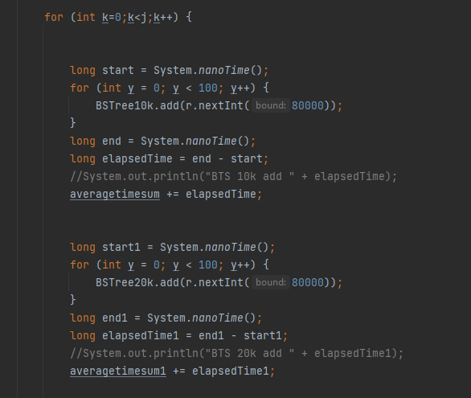

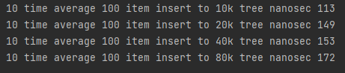
Result

Graph

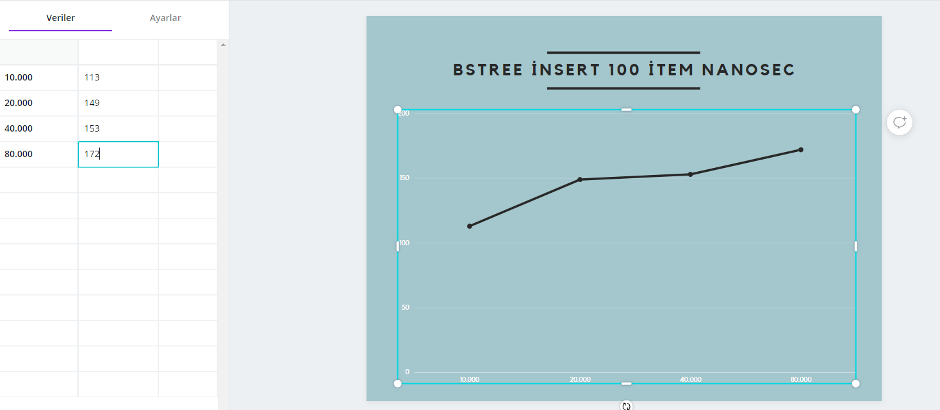

B-Tree

Driver Class
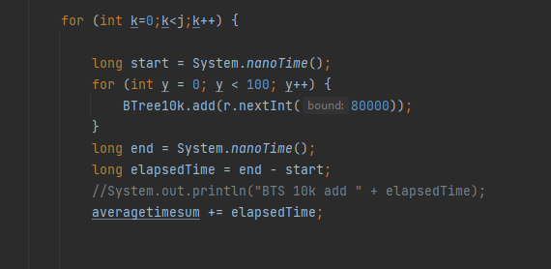

Result
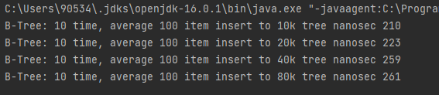

Graph
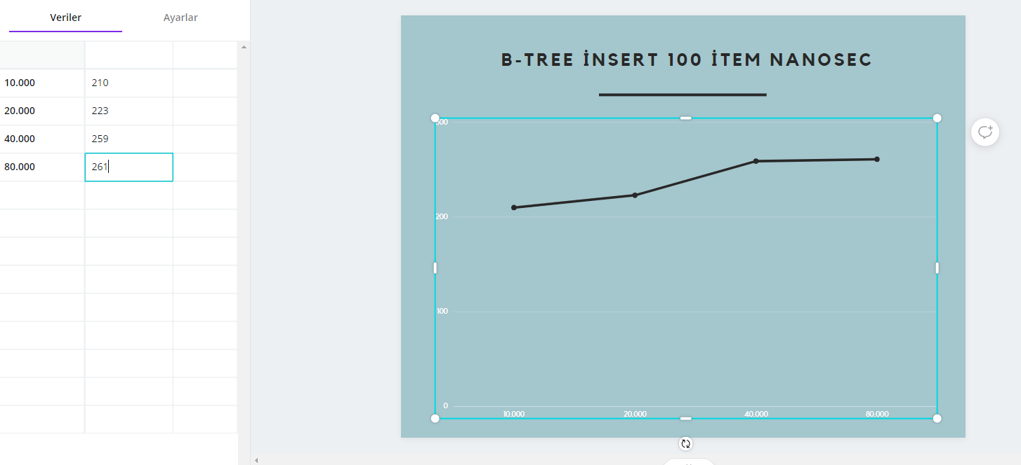

Red-Black Tree

Driver class

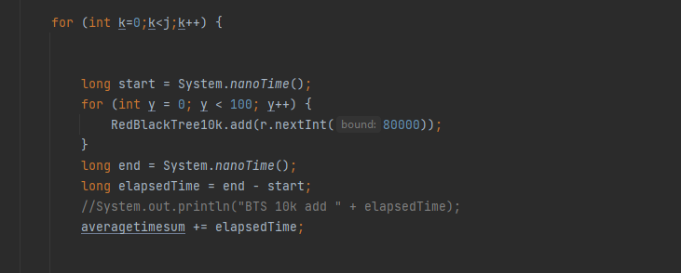

Result

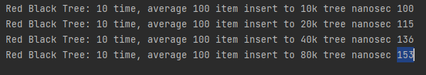

Graph

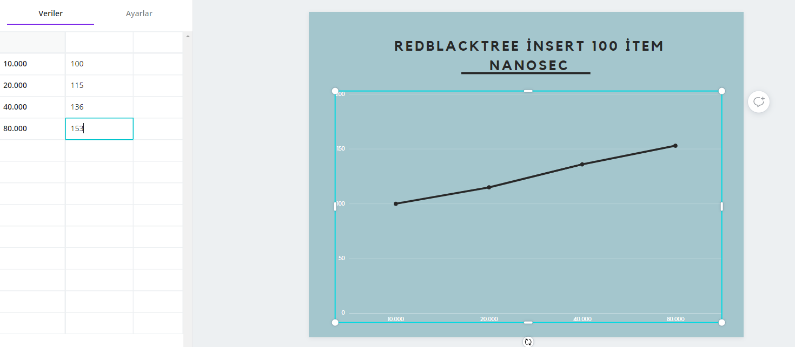

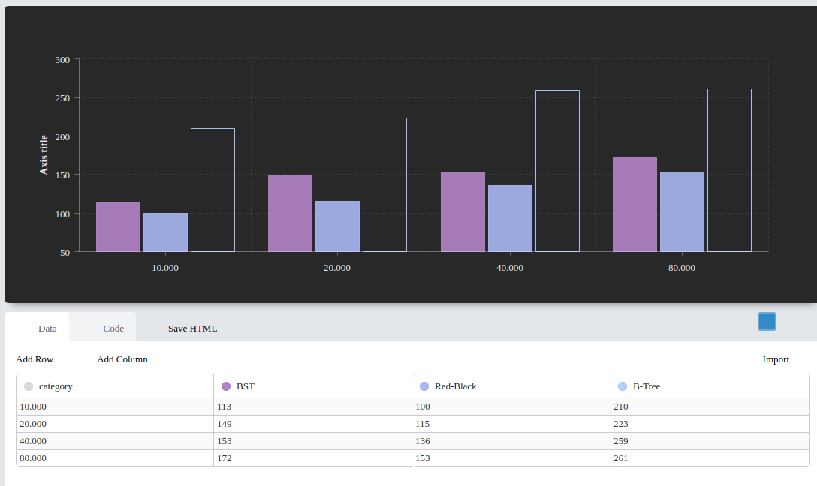

BST Red-Black B-Tree

